This application shows you the questions, provides a place for answers, and shows you what the scorers are looking for.

Date of Application
Name of Organization
Name of Program
Dollar Amount Requested
Total Cost of Program
Organization’s EIN

Part A: Program Budget
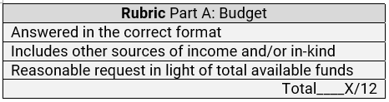
Please review the example budget on the following page.
Follow its format when creating your program budget.

Please include your budget below or as an attachment.

Part A: Program Budget Example.
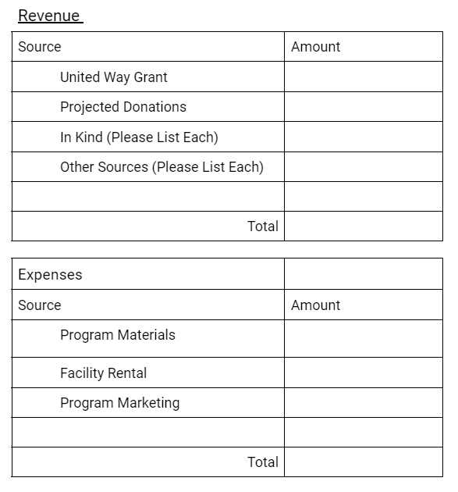
This is not a fill-in template and not exhaustive of possible sources of revenue or expenses.
$ Projected cost of program-specific materials
$ Any other program-specific projected revenue
$ Program-specific donations
$ Requested in application
This is only an example. Submit your program-specific budget.
Total projected $ for program-specific expenses
Total projected $ of program-specific revenue
$ Projected cost of program-specific marketing
$ Projected cost of program-specific facility rentals
$ Program-specific in-kind sources: List each as a separate line expected

Part B: Agency
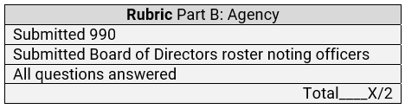
Please attach the following with your application:
- Submit your latest 990.
- Submit your Board of Directors roster highlighting the officers.

Please answer each in full:
The contact person for this program:
Contact person’s title:
Contact person’s mailing address:
Contact person’s phone number:
Contact person’s email address:
The organization’s mission statement:

Part C: Program Description
Question #1. Describe the program
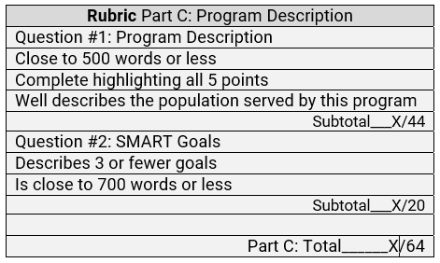
Please limit your response to 500 words or less and use bullet points as appropriate for easier reading. Highlighting your main points allows scorers to see what you want to be known rather than hunting through the response.
Please describe your program, making sure to include each
of the following points below.
- Describe the purpose of the program.
- Describe previous and/or projected outcomes.
- Identify the population this program intends to serve.
- Describe the barriers impacting this population.
- Identify collaborative partner(s), including their relationship and position in supporting this program’s success. Collaboration may be existing or planned partnerships.
Please provide your response below.

Question #2. SMART Goals
Use the SMART goal format to describe the program's goals.
- Click this link for a handy quick guide to nonprofit SMART goals, or go to http://tinyurl.com/5bus4pd3.
- Do not describe more than 3 goals. Please limit your response to 700 words or less.

SMART Goals. For each goal listed, be sure it is:
S - Specific: What needs to be accomplished, who is responsible, and what steps are in the process?
M - Measurable: Your goal should have concrete criteria for measuring progress and staying motivated. Qualitative and quantitative measurements apply.
A - Achievable: Goal(s) should be realistic and checked along the way.
R - Relevant: Does this program strengthen resiliency?
T – Time-bound: Time-related parameters are built so everyone in the program understands the checkpoints. Remember that your program may be the first phase of a potentially ongoing program.
Please provide your response below.

Part D: Program Evaluation
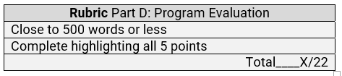
No data or results are expected in this application. Please limit your response to 500 words or less and use bullet points as appropriate for easier reading. Highlighting your main points allows scorers to see what you want to be known rather than hunting through the response.
Please describe your plan for program evaluation, making sure to include each of the following points below.
- Describe what success looks like in terms of the individual, your organization, and the community.
- Describe the measurement tool you will use.
- Describe what data you will collect and how often it will be collected. (e.g., at the beginning, middle, and end of the program? If not, how often?)
- Describe how you will compare early data with the information collected at the end and the criteria used. (Why are numbers going up or down in each category?)
- Please describe your thoughtful plan to share the results with United Way and/or the community. (Remember, the community is looking to fund solutions.)
Please provide your response below.

This completes the 2024-2025 United Way Community Resilience Grant Application.
Please submit your application to CIC@howardandtiptonunitedway.org
The application deadline is Friday, February 16th, 2024 at 11:59pm.
We will send a confirmation of receipt.

This grant was made possible through donations to the United Way of Howard and Tipton Counties.

